Rise Up & Call Her Name
A Woman-honoring Journey into Global
Earth-based Spiritualities

A gestalt of attributes integral to varied cultures, Rise Up presents a textured spiritual inquiry missing from exclusively male imaged, monotheistic belief systems.
Circles of participants undertake personally relevant activities including: experiencing visual images, chants, creative rituals, movement, storytelling, and hands-on art projects such as making improvisational quilt patterns and masks. Participants have the opportunity to develop fresh perspectives on qualities such as fearlessness, compassion, nurturing and the unfolding of personal spirituality.
Ethical principles central to a variety of earth and woman honoring traditions around the globe and throughout history form the core of each session. Knowing there are traditions that value the female but in no way deprecate the male can provide inspiration and sustenance to both women and men.
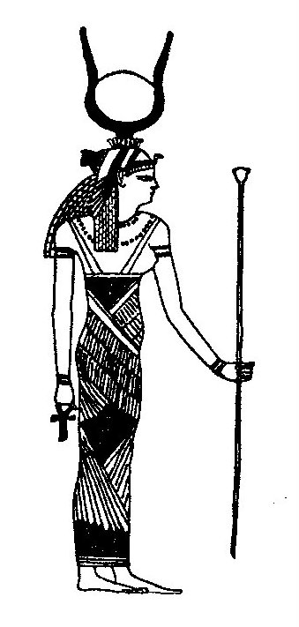
Sacred narratives that honor the cross cultural female divine in Her diverse shapes, colors, sounds and movement teach Her ethical lessons.
During the thirteen sessions, participants meet and interact with:
Lilith, Hecate, Isis, Yoruban Orisha Oya, Yemaya, and Oshun, Outraged Ancestral Mother, Tara, Kuan Yin, Amaterasu, Kali, Taoist Great Round, Pele, Virgin of Guadalupe, White Buffalo Calf Woman, Spider Woman and Changing Woman.
Group sharing is especially rich, often supporting community building that continues even after the course is completed.

The Rise Up website (www.RiseUpandCallHerName.com) provides additional information and resources related to this fascinating journey into the sacred feminine around the world and throughout time.

