VOICES OF CHANGE:
Interviews with Monterey County Activists and Organizers 1934-2015
by the People’s Oral History Project
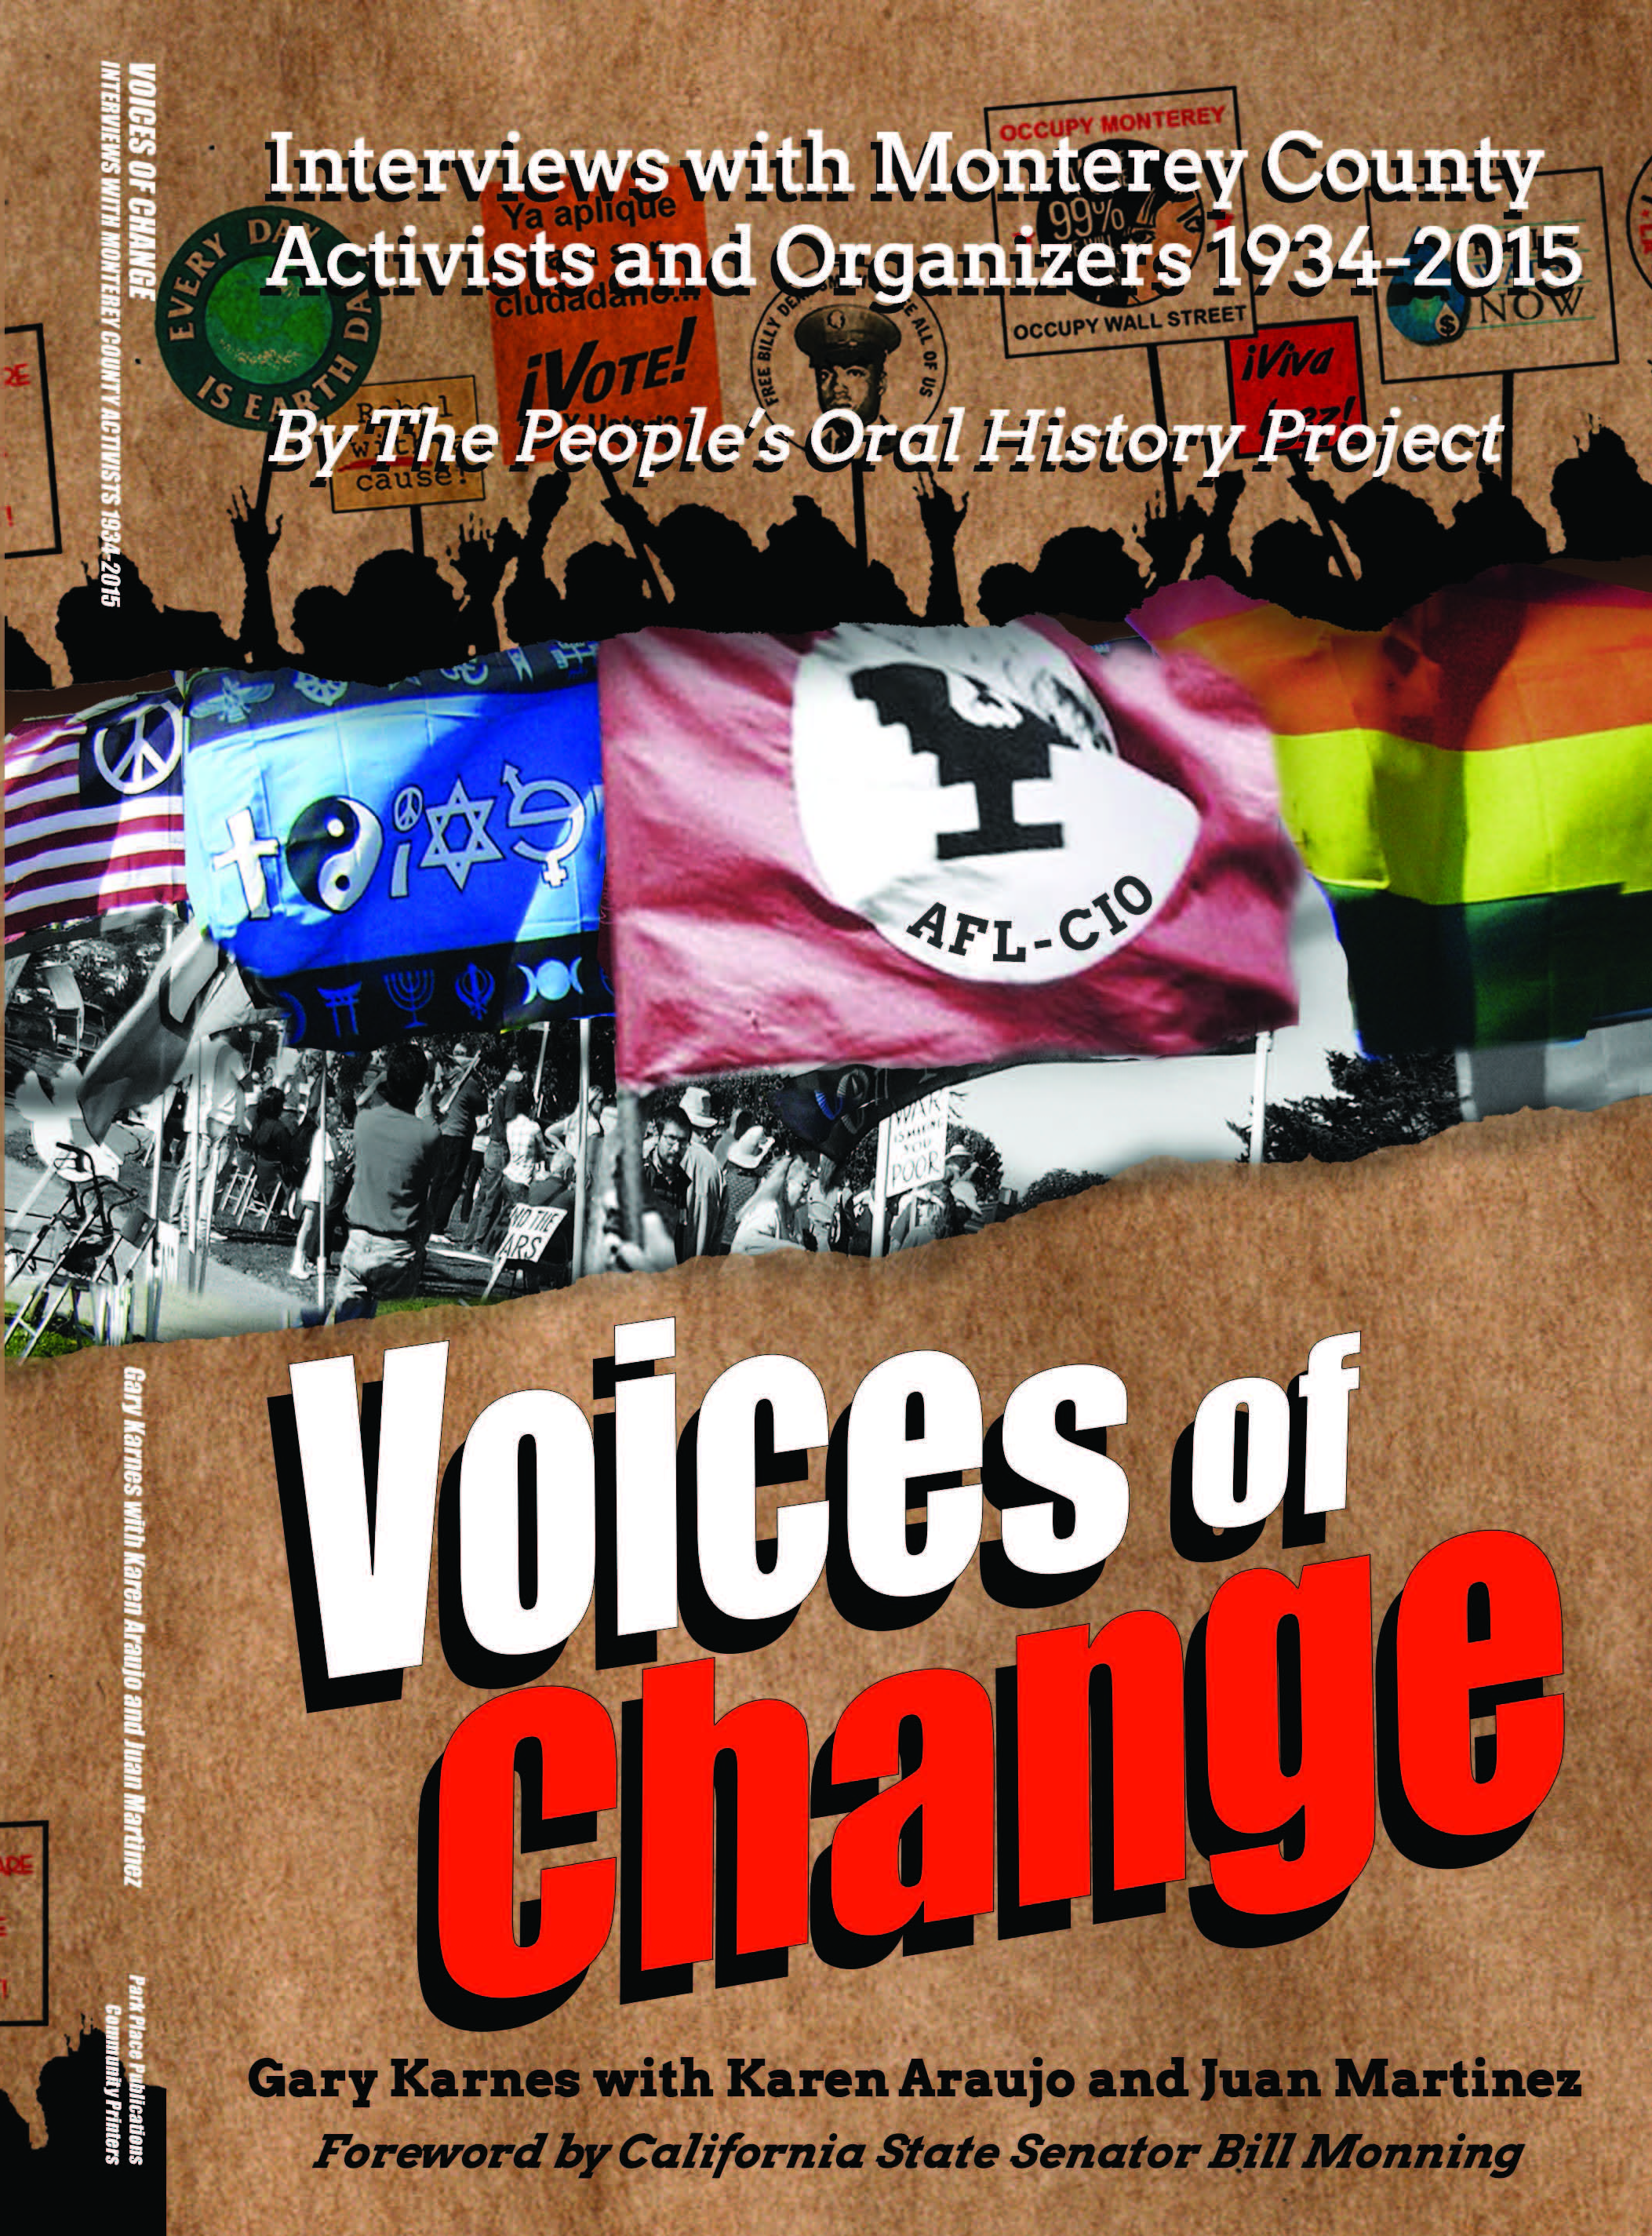
This is a memorable collection of informative and enthralling statements culled from interviews with sixty-three activists. Material written by Rosemary and Howard Matson is included. A description from the editor and activist, Gary Karnes, characterizes the venture:
“Monterey County has experienced a rich history of social and political activism. The individuals who were interviewed for this project took risks, stood up, marched, sat in, sat down, got arrested, joined consciousness-raising groups, fought racism, fought sexism, openly and actively, proudly and loudly called for a more just world that respected Universal Human Rights. They were persistent and resourceful. We honor them. We need to learn from them. The next generation of activists will hopefully find this a useful tool in the struggle for a more peaceful and just society that protests injustice wherever it may be.”
¡Viva La Causa!
The foreword to this book is written by State Senator Bill Monning, who is currently the Majority Leader of the California State Senate. He described the book as: “Our tremendous gains have been tempered by losses and setbacks. It is one reason that this collection of oral histories is so important as it captures forever the voices and stories of those who cared, of those who sacrificed, and of those who struggled against the power structure to make a positive difference in the lives of the underserved and underrepresented. This collection provides not only stories, but also the names of everyday people who dared to make a difference and in so doing claim a place in Monterey County’s history.”
Liz Fisher comments: “Rosemary Matson died before she could be fully interviewed about the many activities she and Howard spearheaded and topics they wrote about. Rosemary was a great archivist. Over the last few years of her life, I spent many hours talking with her and reviewing her files. She entrusted to me her collection of their personal papers and published works. I selected pieces for inclusion in Voices of Change that represent their passionate commitment to social justice and the depth and breadth of their involvements.”
The book is available for $22 + $2 S/H online at American Book Exchange (ABE)
American Book Exchange or through www.peoplesoralhistoryprojectmc.org and
by mail: POHP, P.O. Box 442, Salinas CA 93902—$30+$3 postage (831) 402-9106
Flier prepared by Elizabeth Fisher www.riseupandcallhername.com

